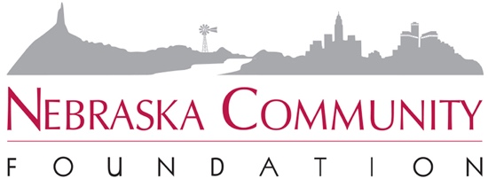

FACT SHEET

NEBRASKA COMMUNITY FOUNDATION
2011 TRANSFER OF WEALTH STUDY

Contact:
Carrie Malek-Madani, Director of Marketing and Communications
402.323.7331; cmalek-madani@nebcommfound.org

- Nebraska Community Foundation released an update to its Transfer of Wealth Study in 2011.

- The 2011 Study updates its original county-by-county analysis originally conducted in 2001–2002.

- The 2011 update indicates that over the next 50 years, more than $602 billion will transfer from one generation to the next in Nebraska. This represents an 84 percent increase over original estimates.

- Every geographic region in Nebraska experienced significant growth in the Transfer of Wealth opportunity. Nebraska is in a strong economic position.

- NCF uses the Intergenerational Transfer of Wealth Study to gauge the potential for philanthropic investment in our communities and to set goals for charitable giving.

- Over the next 50 years, if only 5 percent of the Intergenerational Transfer of Wealth were given back through charitable gifts and endowed in community funds, Nebraskans would have $30 billion held in permanent endowments.

- These endowments could generate about $1.5 billion each and every year to reinvest in Nebraska’s economic development and its quality of life.

- The Transfer of Wealth Study creates scenarios for each Nebraska county, based on extremely conservative estimates of current household net worth, demographic trends, and the potential for charitable gifting.

- Due to outmigration, Nebraska’s most rural counties are experiencing their peak years of wealth transfer now or within the next 10 years.

- The Nebraska Community Foundation works with more than 200 affiliated funds across the state to secure a portion of the intergenerational transfer of wealth for community reinvestment.

