Plattsmouth Community Foundation Fund Fund

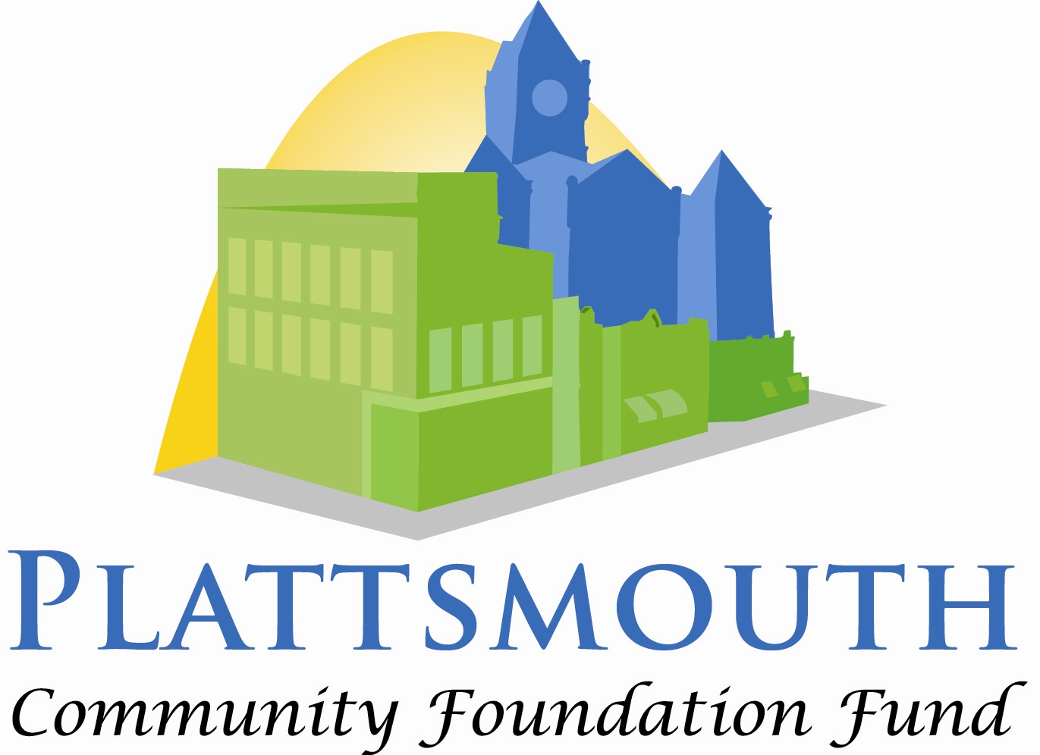

Neil Lancaster

Education Scholarship

Neil Lancaster was born and raised in Plattsmouth. He graduated from high school in 1938 and passed the 17 state exams needed to earn his teaching certificate. His first teaching job was in Weeping Water but he taught throughout Cass County. He was appointed as the Cass County Superintendent in 1960, a position he held until it was dissolved in 2000. Neil Lancaster served two terms on the Plattsmouth School Board, volunteered in the GED program, and participated in many other civic activities. He epitomized excellence in education and established this scholarship to support others with the same passion.

General Information
Name
Street Address
City ST ZIP Code
Home Phone
Work Phone
E-Mail Address
Plattsmouth High School Graduation Year

Continuing Education

What school do you plan to attend starting your sophomore year?

Educational Career

What level(s) are you interested in teaching?
Early Childhood (PreK-2)
Elementary (3-5)
Middle School
High School

What subjects are you interested in teaching?

Interest in Teaching

Teaching is a challenging and rewarding career. Please identify and explain your three most important reasons for wanting to be a teacher.

Community Involvement

The Plattsmouth Community Foundation Fund believes in supporting the community. Please list all school and community activities in which you are or have been involved. Identify any leadership roles you have held in these activities.

Previous Work Experience

The Plattsmouth Community Foundation Fund is impressed with a young person who can balance school and work. Summarize your previous work experience.

Special Teaching Skills or Qualifications

Summarize special teaching skills and qualifications you have acquired from employment, previous volunteer work, or through other activities, including hobbies or sports.

Reference
Name
Street Address
City ST ZIP Code
Home Phone
Work Phone
E-Mail Address

Agreement and Signature

By submitting this application, I affirm that the facts set forth in it are true and complete. If I am awarded a scholarship, I understand that:

I am applying for a scholarship that will be awarded my sophomore year in college as an education major.

In order to receive any funds, I need to contact the Plattsmouth Community Foundation Fund Treasurer with proof of my full-time enrollment in a teacher education program at an accredited institution.

I may receive additional scholarship funds my junior and senior years of college if I continue in a teacher education program at an accredited institution and have maintained a B average each year. I will need to provide the PCFF a copy of my transcript and proof of being enrolled in an education program by June 1st of each year.

Preference is given to candidates who attend a Nebraska college or university.
- Only graduates from Plattsmouth High School can apply for this scholarship.

Name (printed)
Signature
Date

Applications must be submitted electronically to plattsmouthfoundation@yahoo.com no later than February 29, 2024 at 5:00 pm.

