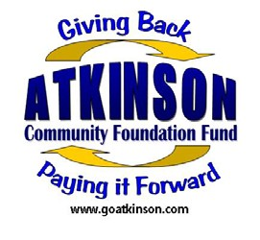
Grant Application
Atkinson Community Foundation Fund
An affiliated fund of the
Nebraska Community Foundation
512 E 5th St, Atkinson, NE 68713

Date: ____________

Applicant Information

Organization Name: __________________________________________

Project Name: __________________________________________

Address: __________________________________________
__________________________________________
Contact Person: __________________________________________
Mobile Number: __________________________________________
Email: __________________________________________

Type:
  - 501(c)(3) Organization (Please submit copy of IRS Letter of Determination)
  - Governmental Entity (village, city, county, school district, etc.)
  - Other – please specify __________________________________________
(Additional information may need to be submitted.)

Instructions:
Please mail your completed application to the address above. Once your application is received it will be reviewed and a representative from the Advisory Committee will contact you after a decision has been made.

Questions:

Feel free to contact Lisa Bilstein 402-340-6188 or Nicky Cadwallader 402-340-2312.

The Atkinson Community Foundation Fund is affiliated with the

Describe the proposed project.
__________________________________________________________________________________________________________________________________________________________________________________________________________________
____________________________________________________________________________________________________________________________________________
__________________________________________________________________________________________________________________________________________________________________________________________________________________

Explain the key benefits for the community of Atkinson or surrounding area and any other goals you have for this project’s impact.
__________________________________________________________________________________________________________________________________________________________________________________________________________________
____________________________________________________________________________________________________________________________________________
__________________________________________________________________________________________________________________________________________________________________________________________________________________

Project Plan

Total cost: _______________________

Total secured from others: _______________________

Total requested from ACFF: _______________________

Balance needed: _______________________

Explain plans for securing the balance of funds:
__________________________________________________________________________________________________________________________________________________________________________________________________________________

If ACFF can provide partial funding to your request, do you feel you can still complete your project/accomplish your goals?

__________________________________________________________________________________________________________________________________________________________________________________________________________________

