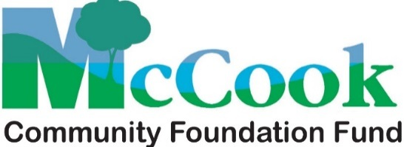

**Bernard and Nelda Haag Scholarship Guidelines**

A $1,000 scholarship is available annually to either graduating seniors or students currently enrolled in college who are from Red Willow, Furnas, Frontier, Hayes and Hitchcock counties. Each applicant must be entering or currently attending an accredited school of higher education.

The focus for selecting the recipient will be based upon leadership and self-motivation through involvement in extracurricular activities in high school; a dedication to agriculture or rural living; a desire to return to a rural area or Southwest Nebraska; lifelong learning; the personal essay; and financial need. A recipient may reapply in subsequent years as long as he or she continues to meet the parameters of the scholarship.

The McCook Community Foundation Fund Scholarship Selection Committee will select the recipient. **The application deadline is March 31st.**

**Barbara Fassler-Neumann Nursing Scholarship**

A scholarship will be awarded annually to students and residents of southwest Nebraska. Preference will be given to graduates from McCook High School or to currently practicing medical professionals who have resided in the area for at least four years.

Preference will be given to applicants expressing a desire to return to or stay within the southwest Nebraska area after graduating or receiving accreditation.

Student Eligibility & Requirements

The applicant must be a graduating senior of an area high school, a graduate of an area high school currently pursuing study in the medical field, or be a resident of southwest Nebraska for four years and have graduated with a high school degree.

The applicant must attend an accredited college, community college, or vocational school.

The applicant shall prepare an essay which describes briefly their proposed or current field of study within the medical field, their reason for selecting this major, and their plans for using their education to return to southwest Nebraska and practice medicine.

The MCFF Selection Committee reserves the right to interview eligible applicants. The McCook Community Foundation Fund’s Scholarship Selection Committee will select the recipient. **The application deadline is March 31st**.

**Nelson Hometown Scholarship**

MCFF no longer administers the Nelson Hometown Scholarship. It is now affiliated with McCook Community College and the Nelson Fellows program.

For more information about the Nelson Fellows program, contact Andy Long, [longa@mpcc.edu](mailto:longa@mpcc.edu) or Bobbi Barton, [bartonb@mpcc.edu](mailto:bartonb@mpcc.edu), [308-345-8127](tel:(308)%20345-8127).

**Application Forms**

Application forms are available from area high school guidance counselor’s offices, McCook Community College Financial Aid Office, by email from MCFF Coordinator Ronda Graff at [mcffund@gmail.com](mailto:mcffund@gmail.com), or by email from MCFF Secretary Peggy Been at [peggy@mnb1.com](mailto:peggy@mnb1.com). The applications are also available on the MCFF page of the Nebraska Community Foundation website: www.nebcommfound.org/fund/mccook.

**All applications are due by March 31st.**

**Mail your completed application to**:

McCook Community Foundation Fund

PO Box 525

McCook, NE 69001

(Please no staples or binders with your application.)