Plattsmouth Community Foundation Fund
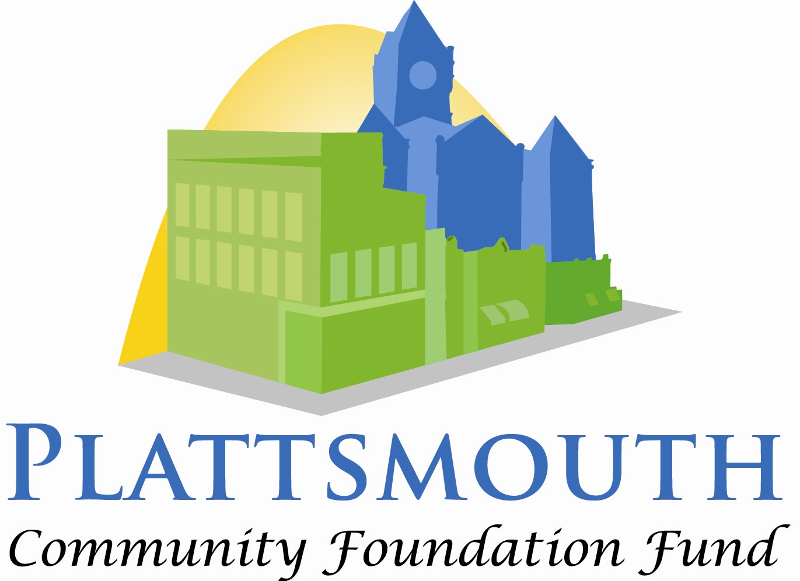

Neil Lancaster

Education Scholarship: Continuation

Neil Lancaster was born and raised in Plattsmouth. He graduated from high school in 1938 and passed the seventeen state exams needed to earn his teaching certificate. His first teaching job was in Weeping Water but he taught throughout Cass County. He was appointed as the Cass County Superintendent in 1960, a position he held until it was dissolved in 2000. Neil Lancaster served two terms on the PCSD School Board, volunteered in the GED program, and participated in many other civic activities. He epitomized excellence in education and established this scholarship to support others with the same passion.

Contact Information
Name
Street Address
City ST ZIP Code
Home Phone
Work Phone
E-Mail Address

Continuing Education

What school do you plan to attend this next year?

Educational Career

What level(s) and subject(s) are you interested in teaching?

Special Teaching Skills or Qualifications

Summarize special teaching skills and qualifications you have acquired during your course work and college education experiences.

College/University Instructor Reference
Name
Street Address
City ST ZIP Code
Home Phone
Work Phone
E-Mail Address

Agreement and Signature

By submitting this application, I affirm that the facts set forth in it are true and complete. If I am awarded a scholarship, I understand that:

In order to receive any funds, I need to contact the Plattsmouth Community Foundation Fund Treasurer with proof of my full-time enrollment in a teacher education program at an accredited institution.
- I may apply to the Plattsmouth Community Foundation Fund for additional scholarship funds my junior and senior years of college if I continue in a teacher education program at an accredited institution and have maintained a B average each year.

- Preference is given to students who attend a Nebraska college or university.

Name (printed)
Signature
Date

Applications must be submitted electronically to plattsmouthfoundation@yahoo.com no later than January 31, 2018​ at 5:00 pm.

