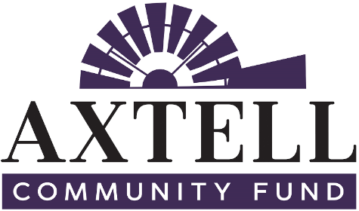

For immediate release
Jan. XX, 2019
Contact: Deb Lundeen
lundeendeborah@gmail.com

AXTELL RISES TO WENDELL FAMILY CHALLENGE

The Axtell Community Fund, an affiliated fund of Nebraska Community Foundation, is thrilled to announce that the Wendell Family Challenge has been met ahead of schedule!

The family of Marjorie and the late Bob Wendell, long time Axtell community supporters, challenged the Axtell Community Fund to raise $10,000 between Oct. 1, 2018 and Jan. 31, 2019. If the goal was reached, the Wendells agreed to match the funds, 2:1 with $5,000.

“Our parents were great Axtell supporters,” said Steve Wendell, the son of Bob and Marjorie. “We know this would please them.”

Not only did the Axtell Community Fund exceed the fundraising goal, it did so an entire month ahead of schedule. In total, $23,000 will be contributed to the Axtell community unrestricted endowment as a result of the challenge. Similar to a community savings account, unrestricted endowments are an important tool to keep hometowns across Nebraska growing, thriving and improving for future generations. While Axtell Community Fund grants out a portion of the income earned by the unrestricted endowment each year to fund projects and programs to benefit the community, the principal remains intact and grows forever.

“The Wendell Family Challenge was the push we needed to establish the unrestricted endowment and we thank the Wendell family for it. We would also like to express our appreciation to the members of the community for the financial gifts they invested in this campaign,” said Dudley Nelson, a member of the Axtell Community Fund Advisory Committee.

Axtell Community Fund (ACF) received contributions from both organizations and individuals who care about the future of Axtell. Among the organizations that supported ACF’s efforts to meet the Wendell Family Challenge were Windmill Housing and Development Corporation and Integrity Construction.

Rod Young of Windmill Housing and Development Corporation said the group has been helping Axtell businesses and people since 1974. According to Young, “Our goal is to make Axtell prosper and we are happy to help get the Fund up and going as it is a benefit to the community.”

Integrity Construction owners Adam Nickel and AJ Dahlgren were both raised in Axtell and although Integrity has completed projects in hundreds of cities across the country, Axtell has remained its home. After a 2018 hail storm, Integrity pledged to give back a percentage of the funds earned through repair work to the Axtell Community Fund.

“Giving back to the community strengthens the community and encourages others to give as well,” said Dahlgren.

To grow the unrestricted endowment and meet the Wendell Family Challenge, the Axtell Community Fund established a Founder’s Club. To be part of the Founder’s Club, donors must contribute $1,000 for the purpose of establishing ACF’s perpetual giving ability. All seven members of the Axtell Community Fund Advisory Committee personally contributed $1,000 to the cause.

Community members are still invited to join the Axtell Community Fund’s Founder’s Club with a deadline of Jan. 31, 2019. Axtell Community Fund welcomes contributions of any size to help build the endowment and invest in the future of Axtell. Checks can be made payable to Axtell Community Fund, and sent to PO Box 74, Axtell, NE 68924.

About Axtell Community Fund
Established in 2017, the Axtell Community Fund envisions a thriving community where residents in all walks of life experience sense of belonging. Its mission to enhance Axtell’s quality of life by inspiring investment and encouraging community involvement is being realized through a community unrestricted endowment and general fund account to benefit community projects, programs and people in the Axtell area. Axtell Community Fund is an affiliated fund of Nebraska Community Foundation.

About Nebraska Community Foundation
Nebraska Community Foundation unleashes abundant local assets, inspires charitable giving and connects ambitious people to build stronger communities and a Greater Nebraska.

In the last five years, 41,776 contributions have been made to NCF and its affiliated funds. Since 1994, NCF has reinvested $323 million in Nebraska’s people and places. For information, visit NebraskaHometown.org.

