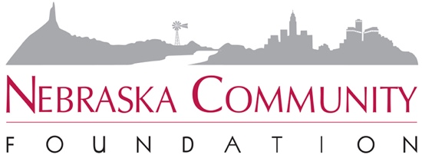

CRITERIA FOR BOARD MEMBERS
Adopted by the NCF Board of Directors * July 30, 2009

“Must Have” criteria – these are the characteristics that all Board members must have
- Passion for (not just interest in) achieving NCF’s vision and mission
- Willingness and ability to commit time both for meetings and for work between meetings
- Willingness to personally contribute annually to NCF giving time, talent and treasure
- Willingness to advocate and help fundraise
- Willingness and ability to collaborate with others outside NCF
- Team player; one who is supportive of group decisions even if not in favor of those decisions
- Good listener
- Thoughtful decision maker
- Integrity
- Understanding of and commitment to the Board member job description

“Wouldn’t it be Nice” criteria – traits we wish someone on the Board had, but not necessary for governing NCF or for all Board members to have
- Experience on the Board of another statewide high-performing nonprofit
- Big-picture thinker
- Connections to potential patrons
- “Facilitative” skills – i.e., the ability to synthesize the thoughts and ideas of others
- Expertise and willingness to use skills in:
  - Communications/media relations
  - Fundraising
  - Governance/leadership
  - Public policy
  - Finance/investments
  - Community economic development

“Never In a Million Years” criteria – the traits we never want to see on the NCF Board
- Individuals who are interested in being on the Board for the “resume value”
- Overcommitted individuals who do not have the time to actively participate
- Individuals who over-promise and under-deliver
- Domineering personalities
- Overbearing egos
- Individuals with a negative frame of reference (who can always identify problems, but not solutions or opportunities)

