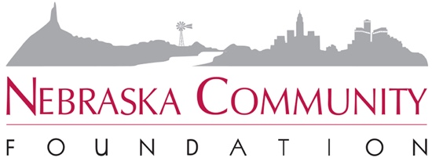

MAKING THE ASK:
A great solicitation happens when the proper volunteer asks the appropriate prospect for the suitable amount of support for a pertinent project.

Make the Appointment
- Send an advance letter to inform the prospect of your project and your goals.
- When making the phone call for the appointment:
  - Think about the reasons you believe in and support this program.
  - Be prepared and know what you are going to say.
  - Make notes and have your materials handy before dialing.
  - Muster your enthusiasm, courage, and persistence.
  - Remember Your Goal!

- Don’t be drawn into making the ask on the phone!
  - Stress your desire to inform the prospective donor in person due to the importance of the project and its ability to greatly impact our area.
  - Give two dates and times and ask which the prospect prefers.
- Send a confirmation note or email prior to your meeting.

Make Your Plan
Will you go alone or with a partner? A team approach is best! Making your asks with a partner offers moral support, better listening, and more ideas when answering questions.

- Practice and preparation are key!
- Know your material and have a plan worked out with your partner.
- Have your materials in order and be prepared to present your proposal.

Make Your Donor Visit
- Start by discussing common interests – this helps set a relaxed and informal atmosphere.
- Listen to your prospective donor for clues during this conversation.
- Move the conversation to the Fund’s efforts, emphasizing key areas of that may address the prospective donor’s interests and concerns.
- Share information about your own commitment to your affiliated fund
- Share the reasons why you are involved with your affiliated fund and why you think it is important.

- Present the case for support – using prepared brochures and visual materials.
- Share information about:
  - Your fund’s present and past accomplishments and success.
  - Your fund’s vision for the future and why/how you support that vision.
  - The goals you believe could be achieve in your community with the Fund’s help.
  - Ask for the gift – be specific and clear. Explain options available to donors.
  - Stop talking and listen to your donor. It is your turn to listen and respond.
- Questions and objections are an opportunity to offer additional information.
  - Acknowledge objections as they arise.
  - Don’t debate with your potential donor.
  - Do correct erroneous information.
  - Return to the subject at hand – their donation to the program.
- Maintain common ground with the 3 F’s.
  - “I feel the same way…”
  - “I found myself asking the same questions…”
  - “I felt this was an opportunity…”
- The simple close: “Can we count on your support….”
- Establish the next step before you leave - set-up a follow-up visit as needed.
- Keep the pledge form with you until the donor is ready to make the actual donation/pledge. This gives you the opportunity to call back, check-in, answer questions, and offer to stop with the form.

No does not always mean No.
There are at least four ways you may hear “No” that may be turned into a “Yes”
No, not at this time. If not now, when?
No, not at that amount. What amount would be appropriate or possible?
No, not for this project. What else may be of interest to this donor?
No, not for WALF. Try to find out why and address that concern.

ALWAYS send a gracious, appreciative and complimentary follow-up letter or note – independent of the results for the visit!

- Thank the potential donor for the time they spent learning about your Fund and the campaign.
- Offer to answer any further questions they may have.
- Reiterate the time-line and current deadlines.

A CHECK LIST OF BEST PRACTICES WHEN ASKING FOR A GIFT
- Be a good listener.
- Be your own charming self.
- Remain positive throughout the meeting with the prospective donor.
- Make your own pledge or gift before soliciting from someone else.
- Use inclusive language.
- Know your prospective donor and do your homework before the visit.
- Be aware of motivation or linkages connecting the donor and Smile in Style.
- Anticipate the prospective donor’s objections and be prepared with answers.

