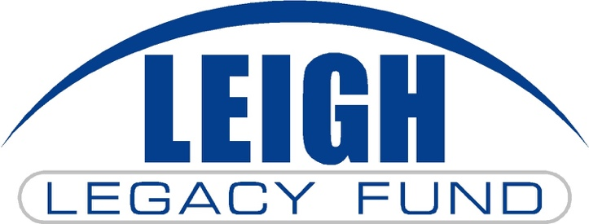

Inspired by the past, focused on the future!
__________________________________________________________________________________
Unrestricted Endowment Campaign Pledge Agreement
_____________________________________________________________________________________________________________________________________________________________________________________________________

This Pledge Agreement is entered into by and between the individual(s) or entity whose name(s) appears below (“Donor”) and Nebraska Community Foundation on behalf of its affiliated fund, the Leigh Legacy Fund (“Fund”).

The Fund has received a challenge grant from a group of “Distinguished Leigh Alumni” as well as the Nebraska Community Foundation. For each dollar (up to $500,000) contributed to the Fund’s unrestricted endowment on or before December 31, 2027, the “Distinguished Leigh Alumni” and Nebraska Community Foundation” will contribute fifty cents for a 2:1 match.

The Donor enters into this Pledge Agreement to establish the level of financial commitment the Donor shall provide to the fund and to establish the actions the Fund will take in reliance on this Pledge Agreement.

Total Gift | $25,000 | $15,000 | $10,000 | $7,500 | $5,000 | $2,500 | $1,000
4 Annual Payments | $6,250 | $3,750 | $2,500 | $1,875 | $1,250 | $625 | $250
8 Semi-Annual Payments | $3,125 | $1,875 | $1,250 | $938 | $625 | $313 | $125
48 Monthly Payments | $521 | $313 | $209 | $157 | $105 | $53 | $21

Donor pledges and agrees to contribute the sum of $______________ to the Fund’s unrestricted endowment, payable as follows:

One-Time Donation

Annually: $__________per year for ___________ years beginning __________________

Semi-Annually: $ __________ every six months for ________ months beginning _____________

Monthly by ACH withdrawal from my bank account: $_________ per month for _______ months beginning _________________.

Donor anticipates fulfilling this pledge with:

Cash Marketable securities Ag commodities Other (specify): ____________
________________________________________________________________________________

Donor Printed Name(s): ___________________________________________________________________

Address: _______________________________________________________________________________

City/State/Zip: __________________________________________________________________________

Phone #: __________________________ Email (optional): _____________________________________

Signature: _____________________________________________ Date: _______________________

I wish to make my donation anonymous.

Contact me about a planned future gift to the Leigh Legacy Fund

