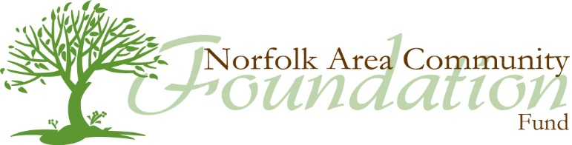
An affiliated fund of Nebraska Community Foundation

FAC EXIT INTERVIEW

Name:

Date Filled out:

- What do you think is important to tell potential FAC candidates about the FAC?

- What did you like about being on the Norfolk Area Community Foundation Fund?

- What things about NACFF could use improvement? Do you have any suggestion for how to make these improvements?

- How do you think the FAC as a whole functions? What improvements to meetings or structure would you suggest?

- At the end of your term, were you comfortable about the direction of NACFF?

- What is the greatest opportunity for NACFF in the next 3 years?

- What is the greatest risk for NACFF in the next 3 years?

- Were you able to use your strengths in your involvement with NACFF? If so, how?

- How would you like to stay connected to NACFF? i.e. committee participation, advisory committee, events, etc.

