How to use this document:

Words highlighted in yellow are to be replaced.

For example, [FUND NAME] becomes the name of your fund, i.e. McCook Community Foundation Fund, Nebraska City Community Foundation Fund, etc.
[HOMETOWN] should be replaced with either the name of your community or the name of your county, whichever best matches the area your NCF affiliated fund serves.
For the following section, please visit www.fivetothrivene.org and locate your county on the interactive map.
In COUNTY, $NUMBER could change hands in the next 10 years. If 5% of that were set aside, our community would receive a $NUMBER boost. (Note: To find your county’s Transfer of Wealth figures, visit www.fivetothrivene.org and click your county on the interactive map. The two figures cited in this paragraph are 10-year TOW and 5% of 10-year TOW. Reach out to us if you need assistance!) If endowed with [FUND], it would be allowed to grow and fuel projects to make our place better for all. Prior [FUND] projects include (list your fund’s achievements!) .
After clicking on your county, you will see a set of data:
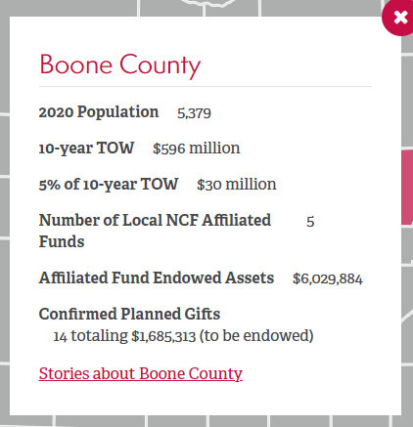
So, in Boone County’s case, the paragraph would read, “In Boone County, $596 million could change hands in the next 10 years. If 5% of that were set aside, our community would receive a $30 million boost.”
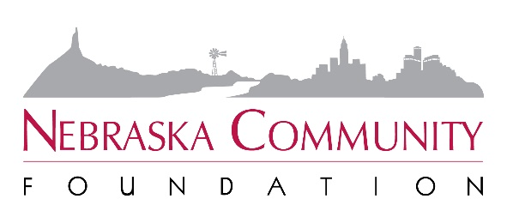
FOR IMMEDIATE RELEASE
November 15, 2021

Contact:
[NAME]
[EMAIL]
[PHONE]

Leave Five for [HOMETOWN] to Thrive

HOMETOWN, Neb. – The [FUND NAME] Advisory Committee invites all community members to join them in seizing the immense charitable potential of [COUNTY] as illustrated by the 2021 Transfer of Wealth Study recently released by Nebraska Community Foundation (NCF).

Study scenarios suggest that in Nebraska, more than $100 billion will transfer from older to younger generations during the next decade. Over the next 50 years, the figure swells to $950 billion. Scenarios are driven by conservative assumptions about the future, based on historical trends, census data, increasing agricultural land values, household income and other key indicators.

There is always an intergenerational transfer as parents pass away and leave their estates to their children, but if the heirs no longer live where they grew up those critical resources may leave our Nebraska hometowns entirely.

The study’s release marks the beginning of NCF’s Five to Thrive campaign, which urges Nebraskans to consider leaving just 5% of their estate to their hometown. Doing so would amount to more than $5 billion in the next decade – and $47.5 billion over the next half-century.

In COUNTY, $NUMBER could transfer in the next 10 years. If 5% of that were endowed, our community would receive a $NUMBER boost. (Note: To find your county’s Transfer of Wealth figures, visit www.fivetothrivene.org and click your county on the interactive map. The two figures cited in this paragraph are 10-year TOW and 5% of 10-year TOW. Reach out to us if you need assistance!)

“If endowed, think of the impact that kind of money could have on education, health, prosperity and quality of life,” said Nebraska Community Foundation President and CEO Jeff Yost. “Think of how it could contribute to a community’s ability to attract quality talent and young families. Harnessing just a small percentage of the transfer of wealth could be a game changer for the future of our hometowns.”

Prior [FUND] projects funded through local philanthropy include (list your fund’s achievements!).

Importantly, many Nebraska counties are approaching or are already experiencing their peak transfer years. The Transfer of Wealth Study illustrates the real urgency to act now to secure this tremendous community-building abundance.

“The transfer of wealth is a significant pathway to strengthening our community,” said [FUND NAME] member [NAME]. “The potential for substantial impact is right in front of us. When we all leave five, [HOMETOWN] thrives.”

Learn more about the transfer of wealth and how you can get involved in this massive opportunity at www.fivetothrivene.org.

About [FUND NAME]
Insert description of your fund

[FUND] is an affiliated fund of Nebraska Community Foundation.

About Nebraska Community Foundation
Nebraska Community Foundation unleashes abundant local assets, inspires charitable giving and connects ambitious people to build stronger communities and a Greater Nebraska.

Headquartered in Lincoln, the Foundation serves communities, donors and organizations by providing financial management, strategic development, education and training to a statewide network of 1,500 volunteers serving over 270 communities.

In the last five years, 45,915 contributions have been made to NCF and its affiliated funds. Since 1994, NCF has reinvested $423 million in Nebraska’s people and places. For information, visit NebraskaHometown.org.

