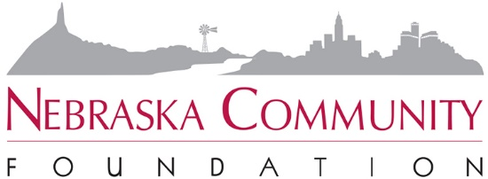

NCF COMMUNITY-BASED AFFILIATED FUND
PLANNED GIVING CAMPAIGN

Many NCF community-based affiliated funds have experienced incredible growth in their endowments due in part to receiving generous planned gifts, given by individuals who felt a deep connection to their hometown and had so much trust in their local fund that they entrusted them with their legacy.

We have also seen several community-based affiliated funds find success by inviting their friends and neighbors to join them in making a future gift in their wills to their hometown. We are encouraging funds to do just that through a dedicated effort focusing on planned gifts, starting with FAC members considering their own planned gifts – leading by example.

Here are the steps to take:
- Watch How to Launch a Planned Giving Program (It’s Easier than You Think!):
Planned giving may offer affiliated funds the biggest (often untapped) opportunity to transform their place. The vast majority of planned gifts happen because someone educated, motivated, and asked the donor to make a gift . . . and they are often the largest gifts a donor will ever leave. This session offers simple and actionable steps to launching or furthering your FAC’s planned giving efforts. We’ll set you up with resources to educate yourself, your donors, and local professional advisors. Planned giving may seem intimidating, but we promise, it’s easier than you think!

The 5 ways to get started with planned giving are to:
- Lead by example
- Engage with professional advisors
- Utilize marketing tools
- Educate others on planned giving
- Partner with NCF

- Launch a Planned Giving Campaign:
Responsible parties: FAC, Affiliated Fund Development Coordinator, NCF Director of Gift Planning
FAC sets goal for number of planned gifts and a participation goal for current and former FAC members.

The campaign will focus on current and former FAC members, close friends and loyal donors. Stories of gifts will be celebrated publicly as appropriate.

- Lead by Example:
Each FAC member is invited to schedule a one-on-one appointment with an NCF staff member at their convenience, with their spouse if appropriate, to have their own conversation about making their own planned gift. Even if the timing isn’t right for an FAC member to commit to a gift at this time, the experience will be valuable. The conversation will be educational in nature.

- Marketing Plan:
  - The fund will develop a marketing plan utilizing NCF-developed materials like those in the Transfer of Wealth Toolkit.
  - The fund will partner with NCF’s marketing department to write and share planned giving donor stories.

- Planned Giving Prospecting:
  - The entire FAC will work together to help compile a prospect list. NCF staff can assist in the prospecting exercise.
  - All FAC members are expected to make one-to-one asks. The fund may add a standing meeting agenda item to review progress toward goal.

- Professional Advisor Outreach:
  - The fund may consider hosting a Professional Advisor Workshop with NCF, perhaps partnering with other regional Community-Based Affiliated Funds.
  - One-to-one outreach to professional advisors is encouraged. The Fund will develop a professional advisor packet to share with local advisors, including FAC members’ own advisors.
  - The NCF Office of Gift Planning is glad to reach out to advisors to share with them both NCF’s and the fund’s mission.
  - The FAC will share its list of professional advisors with NCF to ensure the advisors are all receiving NCF’s weekly advisor e-newsletters.

- Donor Stewardship:
The FAC will plan for FAC members to regularly reach out to loyal donors, including planned giving donors to keep them engaged and say thank you.

